

DASL Notifications
October 10, 2018
10:00- 11:30 AM
AGENDA

- District Settings Management – School Administration – School Building Administration – Notification Rule Configuration
- Required, Opt-In or Disabled
- Filters
- Play/Pause Column

- Building Settings Management – School Administration – School Building Administration – Notification Rule Configuration
- Required, Opt-In or Disabled
- Filters
- Play/Pause Column

- Security Changes
  - DASL Security Role
- Every user wanting to receive Notifications needs a DASL Security Role (including teachers)
- The DASL Security Role needs to have My Account green lighted & Resource Permissions checked
- TIP: Management > Security > Display Role Access (use to check if My Account is green lighted)
- Management > Security > View Roles (use to adjust security roles)
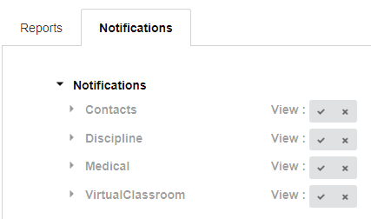
  - Staff Member Job Functions
- In order for users to receive the notifications, they must also have the proper job function
- See handout

  - Reports for Security: Report Builder _DASLSecurity; Ad Hoc Active User Audit; STAFF, or Batelle for Kids export

ProgressBook Suite Notifications
User Settings

My Account – Notifications – Subscription List
- If a notification rule has been set as Required at the district or building level, you will receive the notifications and cannot opt out of them.
- Select the Email box if you wish to receive email alerts in addition to in-app notifications

- If a notification rule has been set as Opt-In at the building level, you can choose to subscribe to such notifications.

- You can subscribe or unsubscribe to available notification rules by clicking Subscribe or Unsubscribe
- Select the Email box if you wish to receive email alerts in addition to in-app notifications
- If applicable, click the Filters box to configure filters for the notification rule
- Click the Play/Pause button to temporarily turn notifications off or on for rules
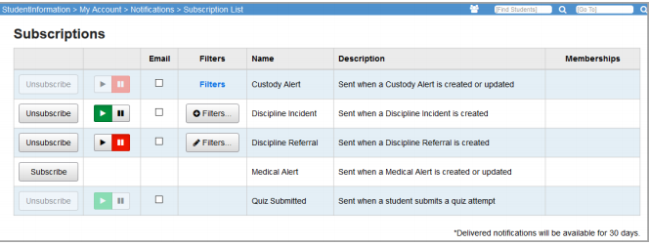

In-app Notifications
Whenever you receive a new notification, a red dot appears next to the bell in your masthead . You can click to view the 15 most recent notifications, within the last 30 days.

To see a list a larger list of notifications click Notifications or My Account – Notifications – Notification List. All notifications older than 30 days are automatically deleted.

