**How to create Co-Teachers for SIS (DASL) and GradeBook**

Go to Course Sections ([StudentInformation](https://si.neonet.org/Default.aspx) > [Management](https://si.neonet.org/Management/Default.aspx) > [School Administration](https://si.neonet.org/SIS/Maintenance/Default.aspx) > [Scheduling Administration](https://si.neonet.org/SIS/Maintenance/Scheduling/Default.aspx) > [Course Maintenance](https://si.neonet.org/SIS/Maintenance/Scheduling/CourseMenu.aspx) > [Course Sections](https://si.neonet.org/SIS/Scheduling/CourseSections.aspx))

Click the Meeting Times Tab and selecting Intermediate. Save.

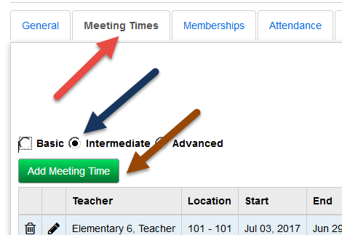

Click Add Meeting time. Select the Teacher, Location and CHECK the Teacher of Record box. Save Meeting Time. Repeat for each teacher needed. Any teacher checked “Teacher of Record” will move over to GradeBook.

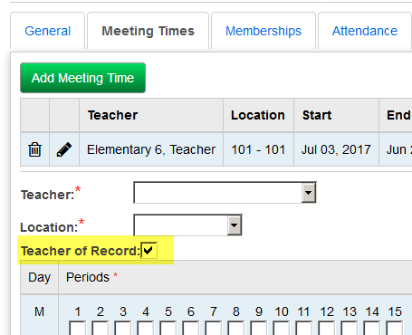

Please note, there is a Teacher of Record Box on the Teacher History Tab. This is for EMIS and will not send the additional teacher to GradeBook.

In GradeBook, both teachers will have role of Primary on the class in GradeBook. When running reports in GradeBook, a random teacher will be displayed if both are primary. This can be adjusted on the Staff tab of the Classes in GradeBook.

SIS (DASL) Schedule Cards and SIS (DASL) Report Cards print any/all teachers. Does not need box checked.

GradeBook – the name on the Homeroom is the name that is printed on the students report cards. If teachers’ names appears next to the class/course, GradeBook will print the name in alphabetic order IF both have the same start date. If one teacher has a more recent start date on the Staff tab on the class in GradeBook and both are primary, the teacher with the most recent start date will be displayed.